How to use

Introduction
In this tutorial we shall be using our offsite cloud server
Which is accessible in the demo version

Login
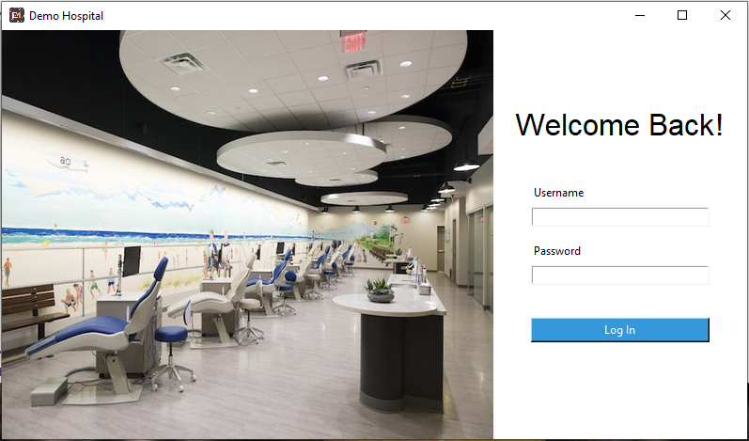

Administrator
- Username; 1
- Password; 1

Doctor
- Username; 2
- Password; 2

Nurse
- Username; 3
- Password; 3

Pharmacy
- Username; 4
- Password; 4

Laboratory
- Username; 5
- Password; 5

Cashier
- Username; 6
- Password; 6

Getting Started

Adding/editing/deleting staff to the database

Rights:
Only Administrators can do this.

Section:
Accounts section
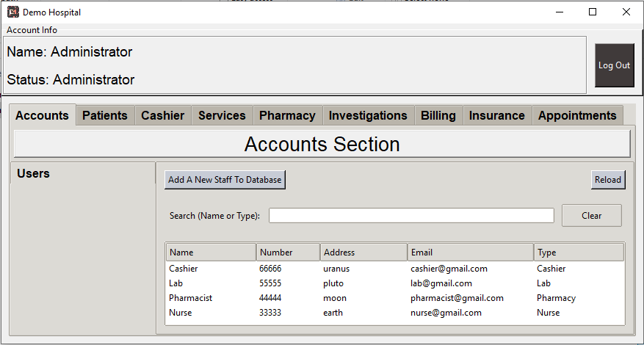

Actions:
- Add a new staff
  - Click Add A New Staff To Database
  - Fill in the relevant information
- Edit/delete staff information
  - Click any staff in the list

Adding Services (Fees, Labs, Investigations, Procedures) to the database

Rights
- Administrator
- Doctor with supervision rights
- Nurse with supervision rights
- Lab with supervision rights

Section
- Services
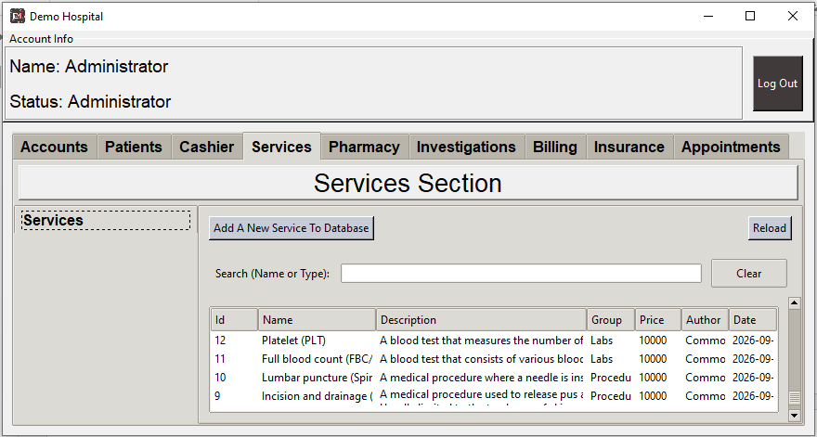

Action
- Add a new service
  - Click Add A New Service To Database.
  - Fill in the relevant information.
- Edit/delete service information.
  - Click any service in the list.

Adding Drugs and Consumables to the database

Rights
- Administrator
- Doctor with supervision rights
- Nurse with supervision rights
- Pharmacist with supervision rights

Section
- Pharmacy

Action
- Add a new drug or service.
  - In the Stocks tab, click Add A New Product To Database.
  - Fill in the relevant information.
- Edit/delete stock information.
  - Click any product in the list.

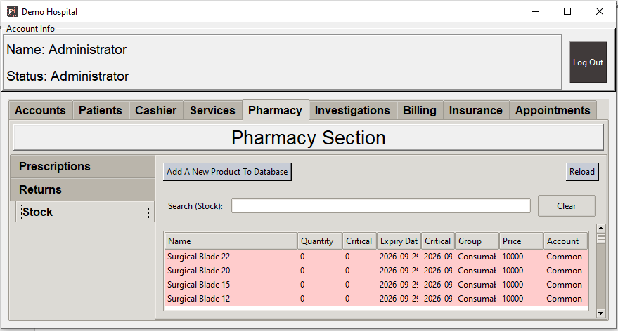

Adding Insurance Companies to the database

Rights
- Administrator
- Cashier with supervision rights

Section
- Pharmacy

Action
- Add a new insurance company
  - Click Add Insurance Company
  - Fill in the relevant information
- Edit/delete insurance information
  - Click any company in the list and edit as necessary
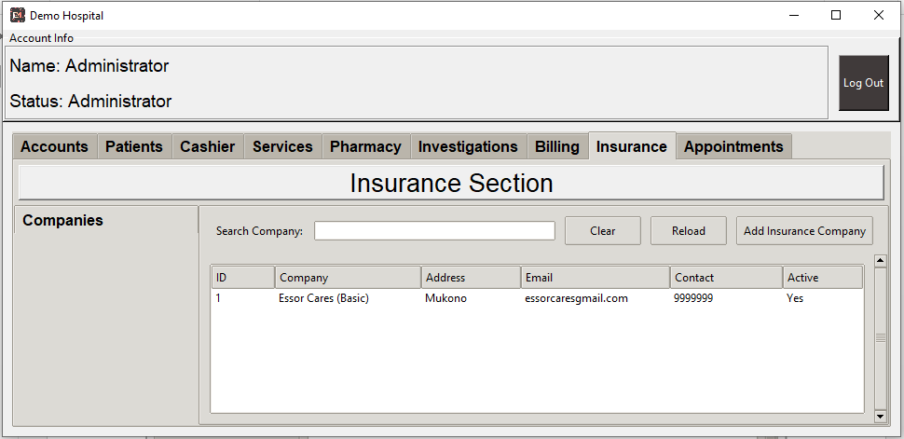

Adding Patients to the database

Rights
- Administrator
- Doctor
- Nurse

Section
- Patients
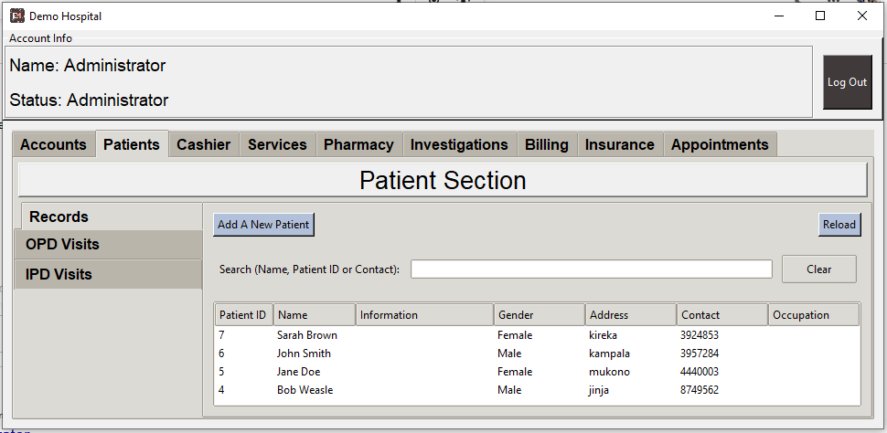

Action
- Add a new insurance company
  - Under Records tab, click Add A New Patient
  - Fill in the relevant information
- Edit/delete patient information
  - Click any patient in the list and edit as necessary
  - You can also add a patient visit or create an appointment
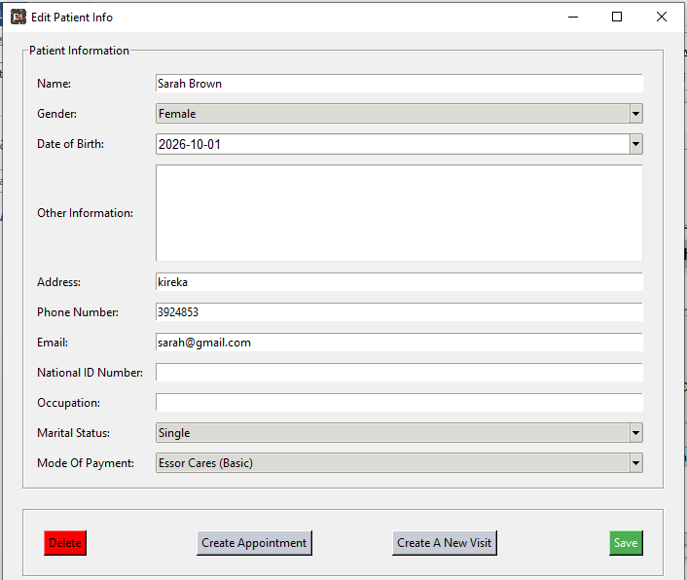

Patient Encounter Scenarios

Receptionist
- In the “Patient Section”, under the “Records” tab, search and select the patient that has come for a visit.
- In the popup, click “Create A New Visit”.
- Another popup will appear
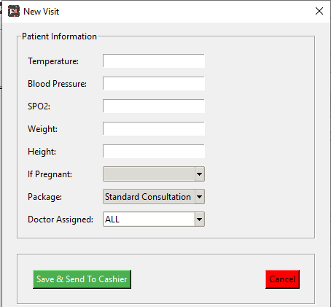
- Enter the patient vitals and other information (Not a must).
- Once done, click on “Save & Send To Cashier”.
  - Only patients that have paid can appear under “OPD Visits” after activation by the cashier.
  - Therefore after the receptionist, the next point is to the Cahier’s desk.
- Hints; It is much easier to search a patient ID instead of typing in long names.

Cashier
- In the “Cashier Section” under the “OPD Visits” tab, the cashier can search or select the patient.
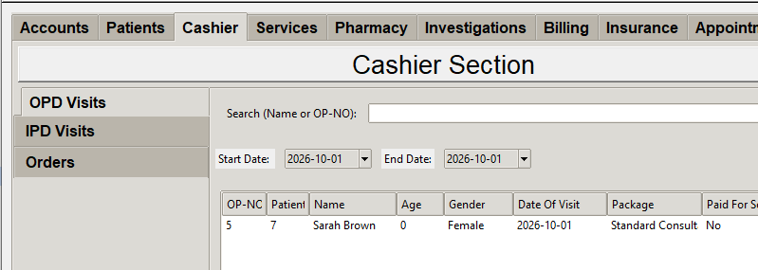
- On selection of a patient, a popup will appear as shown below.
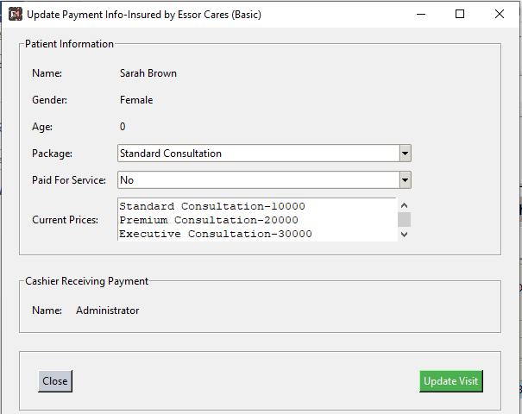
- Choose the consultation package.
- Confirm payment for services
  - No-if no payment was made
  - Insured-after confirmation with insurance company
  - Yes-after getting the cash from the patient
- Click “Update Visit” to activate the patient OPD Visit.
  - Now that the visit is active, the doctor can now access the patient.
  - Therefore the patient can now go into the consultation room.

Doctor
- In the “Patient Section” under the “OPD Visits“ tab, a list of activated patients will appear.
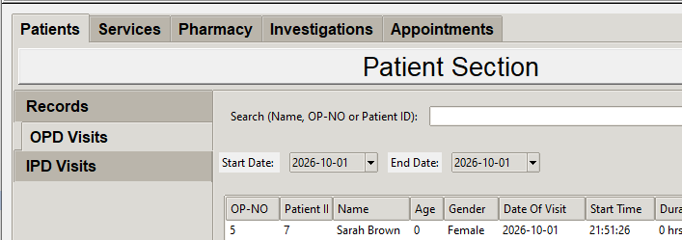
- Select the patient and a popup window will appear as shown below.
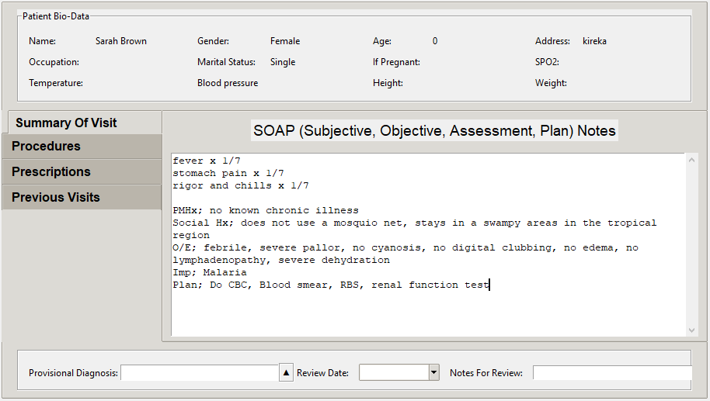
- In this popup, the doctor can document and request for various procedure, labs, medication etc.
  - “Summary Of Visit” tab; here the clinician documents a summary of the visit.
  - “Procedures” tab; to request for services/procedures such as Labs, Imaging, Fees.
  - “Prescriptions” tab; to request for drugs and consumables.
  - “Previous Visits” tab; to see the previous visits.
- Once the clinician is done documenting, the patient can either go to the lab for investigations or to the pharmacy for medication.

Investigations
- In the “Investigation Section” requested lab tests, procedures, fees can be seen.

Pharmacy
- In the “Pharmacy Section” under the “Prescriptions” tab, various drug prescriptions will appear.

Billing
- In the “Billing Section” you can view and document the expenditure of any patient by each visit.
- This is important especially for the insurance patients.

Deployment
- Are you willing to try out the software in your facility?
- Contact us on 0752074238/0771664799 for more information.

Terminology
Organization: The people, entity or purchaser of the product.
Devices: This refers to desktop or laptop computers

Installation Requirements
This can done by our team on the organization’s premises.

Software
- Made available once payment is made.
- Software installation, modification of settings and testing is done on the organization’s premise.
- The software works on Windows, Linux and Apple systems.

Hardware

Servers
This is where the data is stored, retrieved, written and deleted from.

On premise Cloud/Server based systems

Setup
- Onsite server with a static dedicated IP (This can be NAS (Network storage system)
- Computers
- Network switch
- Ethernet cables

Advantages
- No Monthly subscriptions
- Independent of internet shutdowns

Disadvantages
- Initial cost is high
- Requires computer knowledge

Off premise Cloud/Server based systems

Setup
- Computers

Advantages
- No Monthly subscriptions
- Independent of internet shutdowns

Disadvantages
- Initial cost is high
- Requires computer knowledge

Computers
- These are the devices used to communicate with a server.

Minimum number of devices
- The number can be range from 3 to more depending on the organization’s setup.
- Our team recommends at least 7 devices;
  - 1 Device for the reception
  - 1 Device for the cashier/biller
  - 1 Device for consultation room
  - 1 Device for ward
  - 1 Device for the laboratory/procedures/investigations unit
  - 1 Device for the pharmacy
  - 1 Device for the administrator

Considerations when buying a device
- Ability to handle power black outs
- Accessibility to internet

Pricing

Licensing Model
The software uses a “Concurrent User” licensing model. This means that one purchase can be accessed by all individuals in the organization.

Price
Software | 1,200,000 | Onetime purchase and installation fee (all computers on premise)
Training | 800,000 | For every training session (3 days training session onsite)
Hardware | 0 | Variable, as an organization may have its own hardware setup
Support | 300, 000 | Yearly
Maintenance | 0 | One time purchase that will not be maintained
Server | 100,000 | Every month for those without servers
Expanding | 100,000 | For every visit to add computer/s to the system

Terms and Condition
Our team is willing to support you through the experience of the EMR however it will not be held responsible for any data loss.

